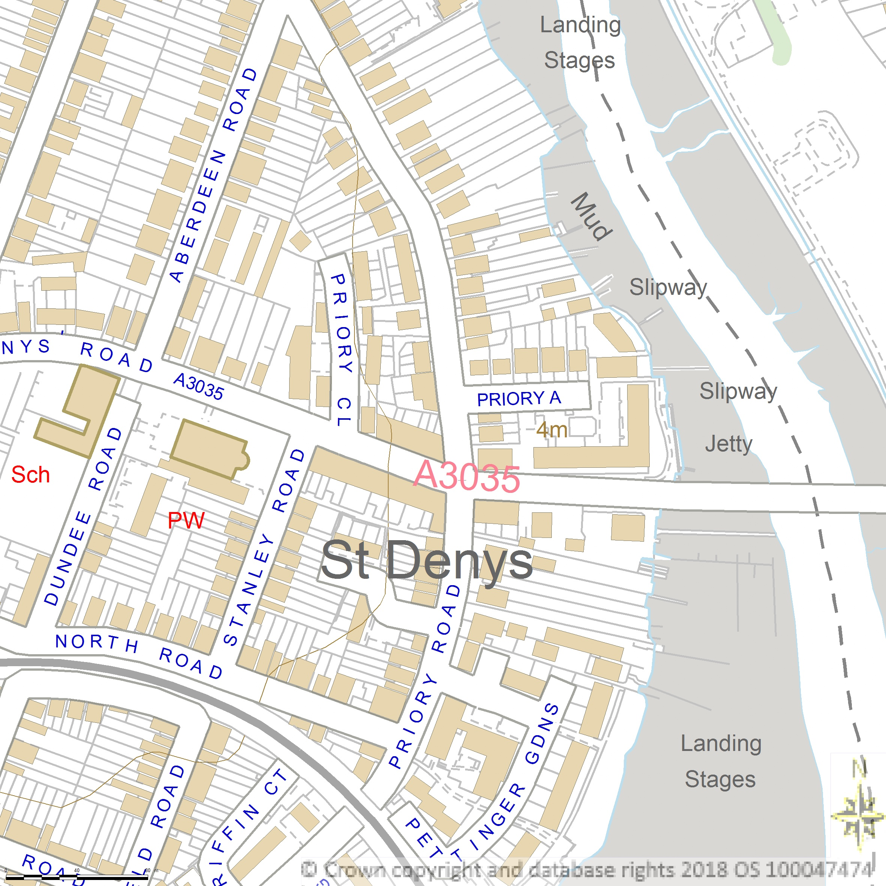
Vector Map Local 500m x 500m
SCALE 1:2500
CENTRE COORDINATES: 443581, 114101


Supplied by Streetwise Maps Ltd
www.streetwise.net
Licence No: 100047474
28/07/2026 15:04:13

